Jasraj Chhokar- jsc53, Alistair Chua - ac2160; Luca Gabella - lmg49; Victor Taiwo - vt239

Covid 19 Data Report

Introduction

This is a report regarding Covid-19 case data from various nations across the world. From the beginning of the pandemic, records of those infected with the virus have been recorded. This report will highlight the comparison between cases and deaths in the United Kingdom and the United States; the cases recorded from China at the beginning of the pandemic; the trends of cases and deaths over the years in the month of January and the reasons for why they may be so different; and finally we will look at 2021 Covid data for Afghanistan looking at how different seasons affect the rate of infection and the number of deaths recorded.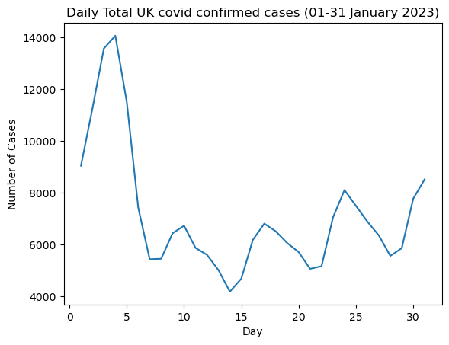

UK and the US

We are investigating the trends of the UK 2023 Covid Dataset for the dates of 01/01/2023 to 31/01/2023. Looking at the graphs provided, we can see that in the UK the number of confirmed cases rose from 01/01/2023 to 05/01/2023 from 9048 confirmed cases to 11502 confirmed cases. However, from 05/01/2023 we can see the decrease of confirmed cases over the remaining days of January 2023 as cases per day decrease with exception on dates of 9,16,23 and 31 of January.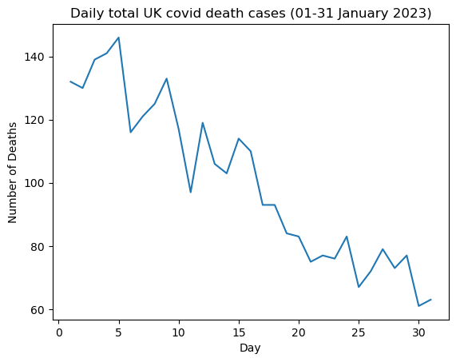

Overall we can see that confirmed cases in the UK decreases over the month. On the graph showing UK death cases, we can see a similar trend to confirmed cases. The overall number of deaths per day decreases over the duration of the month but the decrease of death cases is more prevalent shown by the graph presented. 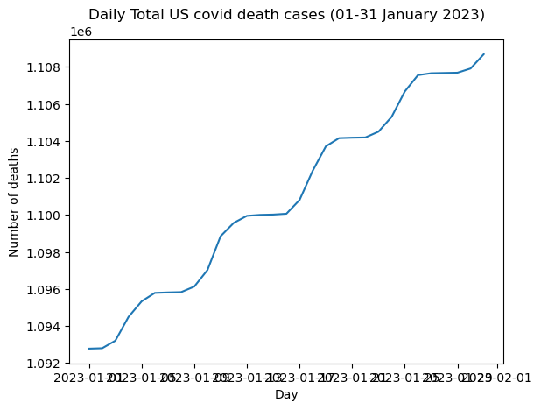

Additionally, we have examined trends of the US 2023 Covid Dataset for the same time period as the UK 2023 Covid Dataset. The graphs present show that there is an increase in both confirmed cases and death cases over the time period with fluctuations which is more consistent in the US compared to the UK as we can see that the UK data has very erratic shifts as seen on the graphs above. The difference in the values and data is due to the difference in the population sizes of the countries as the US has a higher population size compared to the UK which displays why there is a higher number of confirmed and death cases between the two nations.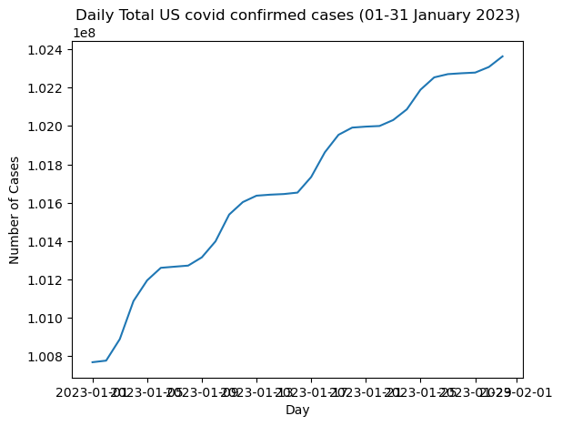

China at the start of the Pandemic

When looking into China, we specifically refer only to the data recorded by Mainland provinces and no other territories. The time period looked at in this report was between January 22nd 2020 and March 1st 2020. Though beginning with 547 cases recorded on the 22nd, in a week the number of confirmed infections was 10x more than the first day. The confirmed cases grew rapidly over the course of this time period and though the number began to level off at around 74,500 cases on the 20th of February, the peak number of cases still reached 79,826 on the 1st of March. 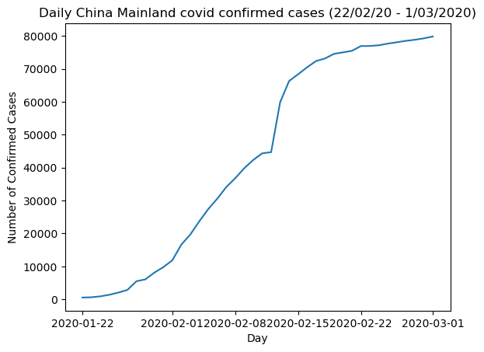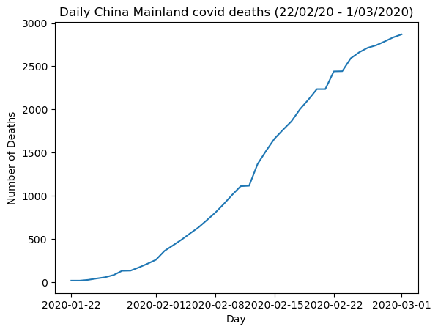

In regards to the total death records, the initial record at the start of this period was fairly low with 17 people registered as dead due to the virus.Though this was the case, according to the data recorded the rate of deaths grew exponentially until the 20th totalling 2,236 people declared dead due to Covid-19. From this date, the amount of deaths started increasing at a slower rate after the 20th of February with the total deaths being 2,870 at the beginning of the month of March.

The number of people recovering from Covid-19 at this time started off quite low with a very low rate of increase. However, this changed quite quickly from the 7th of February. Previous to this date, around 200 to 300 were recovering per day. On the 7th, 522 people were recorded to have recovered from Covid. This increase of people recovering grew even more with data showing the numbers of those who recovered after the 14th of February. There was a sharper rate of people recovering from the virus which was proven by the records per day going up by thousands rather than by hundreds. 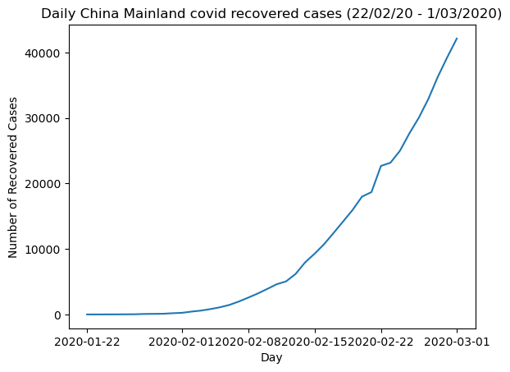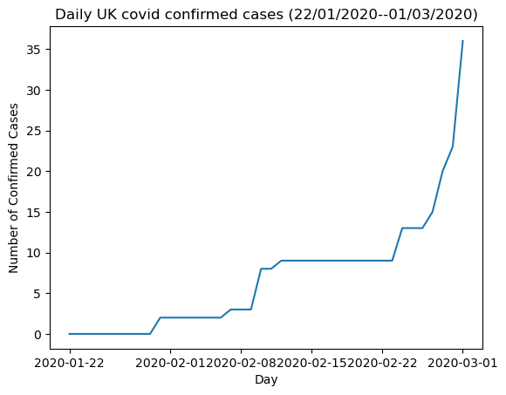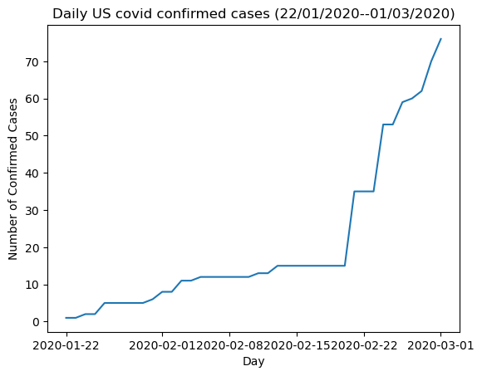

In contrast, the UK and US had slightly different sets of data compared to China but similar compared to each other. The China data has substantially larger quantities compared to the US and UK but as date approaches March, China confirmed cases begin to plateau whereas US and UK confirmed still increase at a large rate with the UK seeing its greatest increase from the 29th of February to 1st of March. 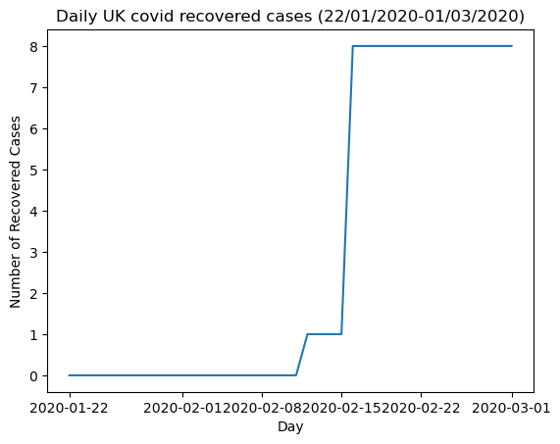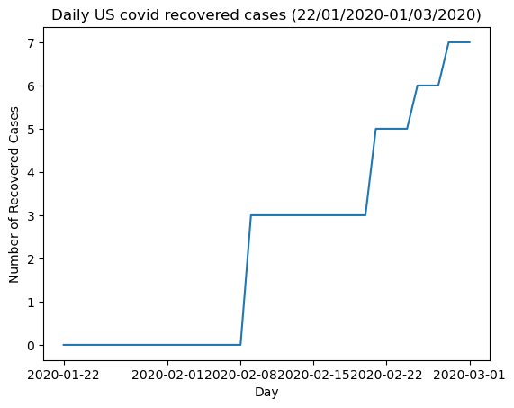

The death graphs for all three countries are very different though with China showing a relatively steady quantity of deaths from day to day, as compared to the UK which shows deaths much less regularly therefore the graph jumps. The US does not show any deaths until February 29th leading to most of the graph being flat.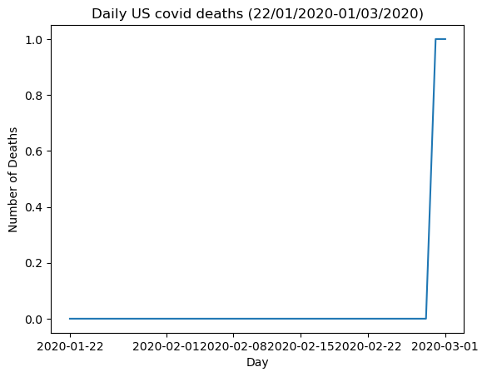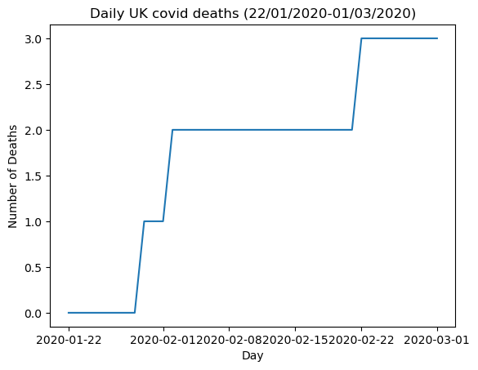

Finally, the recovered graphs all follow similar patterns of fairly consistent recovery rates throughout the entire time period, the UK and US graphs seemingly have more jumps but this is due to the substantially lower numbers of data involved.

Yearly Trends for the UK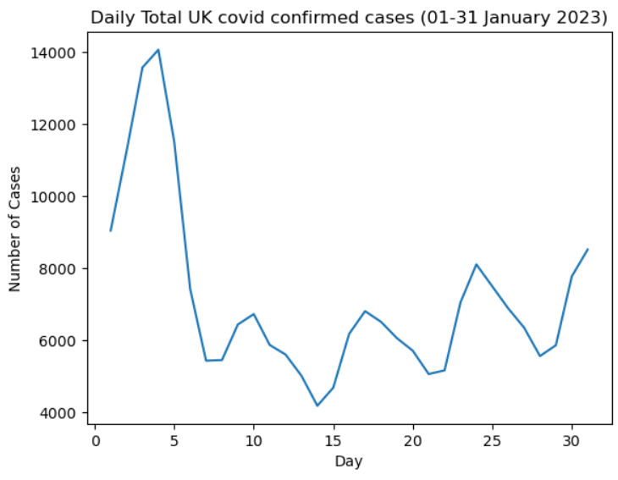

We investigated the yearly trends for the UK from 2021 to 2023. We have discovered common trends that reoccur each time. One observation we found was that the confirmed infections tend to have a spike in the number of cases recorded near the beginning of each month. In early January 2023, the number of cases reached its peak at around 14000 cases, however it rapidly decreased to around 7000 cases. This trend also happened in the 2021, the peak being around 75000 cases but this time decreases with a lower gradient around 40000 cases. The only year that doesn't follow this trend is 2022. Instead, it gradually increased from 1.3 million cases to 1.65 million cases by the 30th of January. 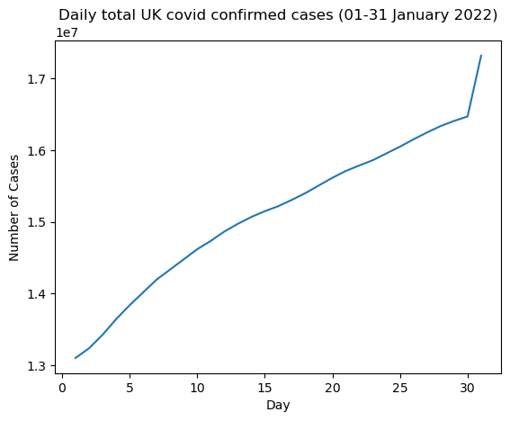

Another discovery we found is that, in the years 2021 and 2023, the confirmed cases seem to have small resurgences throughout the whole month, the differences being that, in 2021, with each consecutive spike, the peak of the jumps are always smaller than the previous spike, decreasing in the number of cases each time.

On the other hand, with 2023, after the first spike in number of cases, the cases once again surge in number of cases, but this time, each peak is higher than the previous, increasing in number of cases by the end of the month but still smaller than the first massive spike in the beginning. The only outlier that doesn't follow this trend is 2022. This year does not appear to have any resurgences in the number of cases for January.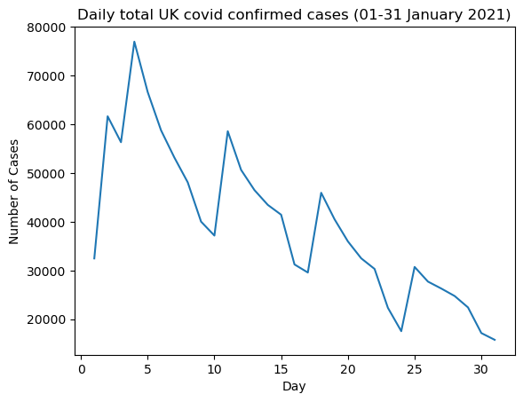

Moving onto the other side of the data, similar trends also appeared in the UK COVID death cases. The first finding that was uncovered was similar to the confirmed cases where there were spikes in values. With the same trend that the beginning of the month has a massive jump in the number of cases compared to the whole month. 2022 tends to keep having a consistent pattern of spikes when 2023, has a more erratic fluctuation in number of cases, but at the same time decreasing in number of cases. When compared to 2022, it has a small change in its shape. 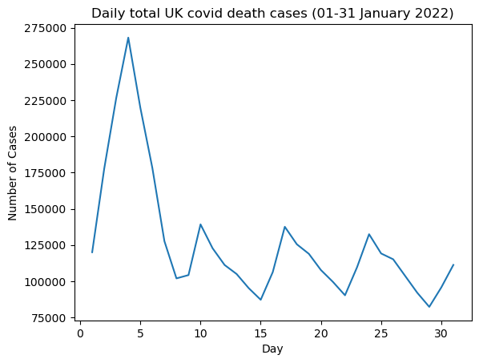

The year that deviates from this trend is 2021. The graph has more of a mountain shape, starting off with a small number of death cases, until it reaches halfway through the month of January where it hits the value of around 1450 casualties caused by COVID. Soon after, the value of death cases starts decreasing again with small jumps.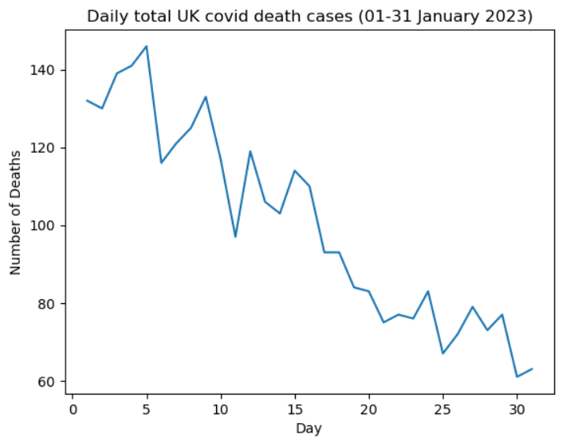

Ultimately, the years 2022 and 2023, confirmed cases and death cases graphs, have similar trends, having large spikes in the beginning and small resurgences that appear throughout the whole month. The beginning of the month has more cases for both graphs than the end of the month. The outlier being 2021 in both cases, following a different trend. This could be because of the lack of vaccines during the time so the behaviour of COVID during those times were more unpredictable and violent.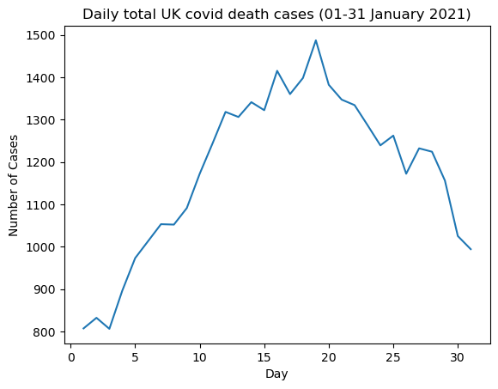

Compared to 2022 and 2023, where vaccines started to be developed and distributed to the country, this would have allowed both statisticians and researchers to be able to predict and analyse the corona virus behaviours and trends.

The 2021 Covid Data for Afghanistan 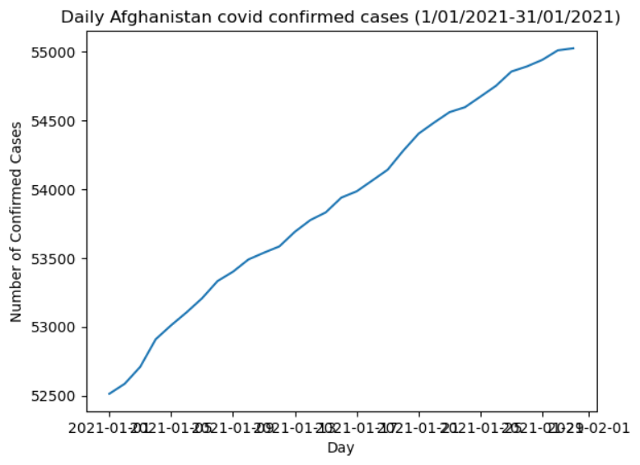

As well as the data produced for the UK, US and China, we looked to investigate how the coronavirus impacted Afghanistan during Winter and edging into Summer. We chose Afghanistan due to it being a part of the middle east and having such polarising seasons with summers able to go to 48 degrees Celsius and winter in the past having a cold snap of -33 degrees Celsius. For this investigation we chose January and June with both being in the year 2021.

The data for the month of January did not increase exponentially as the month went on but instead had a steady increase throughout. The data had an initial record of 52,513 confirmed cases, 2201 deaths and 41,727 recoveries from Covid-19. The number of confirmed cases were tallied to be 2,510 in the entire month with 5,952 people listed as recovered. In the same month, 199 people were registered as deceased due to the virus. As the graph depicts, the rate was fairly consistent and even began to reduce its gradient off towards the end of the month.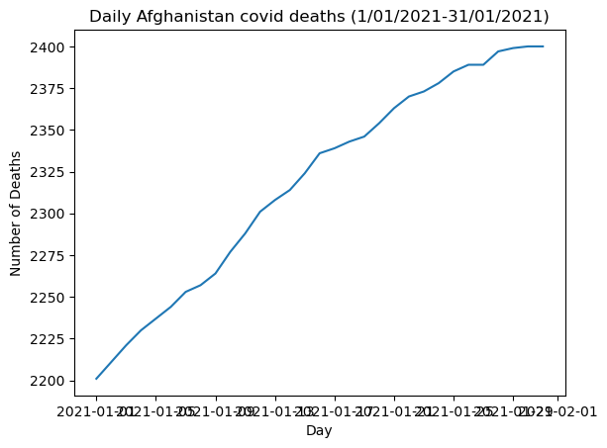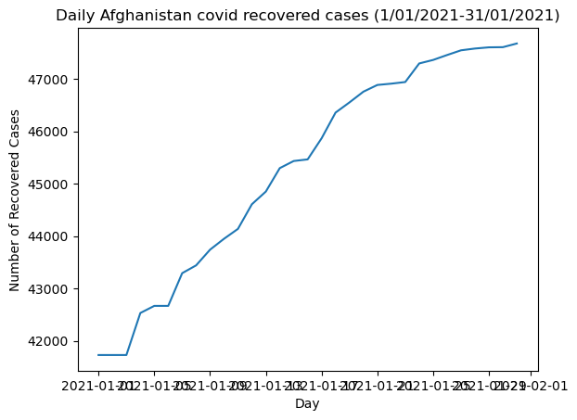

The summer months provided a much more different set of data. The different areas all displayed a large increase in the month of June 2021. The data regarding confirmed cases still showed a linear gradient but had a much larger impact in this instance. The initial number of those cases was much larger than that of January of the same year totalling at 72,977 confirmed cases.

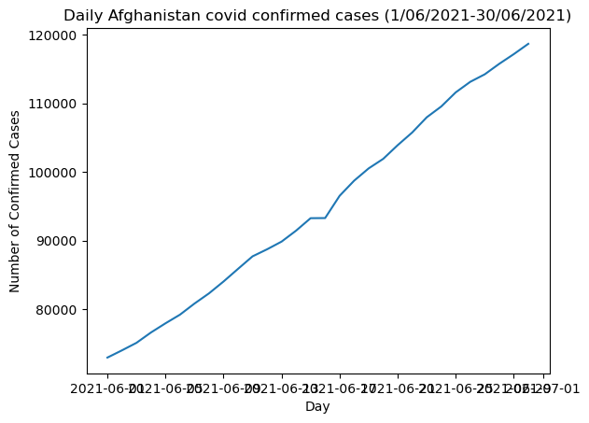

This number went up by approximately 45,700 by the end of June with the final value for confirmed cases being 118,659 cases. In a similar fashion, the total number of people who recovered from the virus started at 57,741 at the beginning of June and this then reached 71,012 by the end of the month. Finally, the record of those who died due to the Covid-19 virus became 4,871 as June was ending, with 1,898 confirmed as dead throughout June.

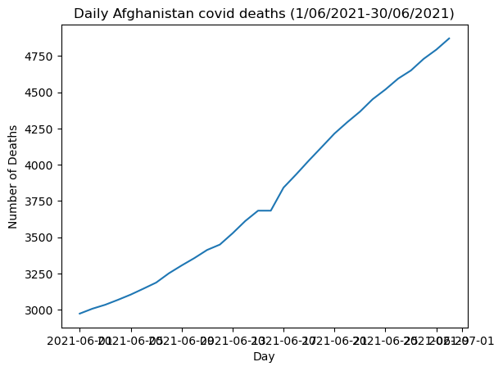

These two months clearly show how, in Afghanistan during the year 2021, the winter months did not prove to be as dangerous in regards to infection and death rate in comparison to the summer months. January showed that though the virus was spreading, it was not nearly as detrimental as June. In Afghanistan, the month of June 2021 proved to have a higher rate of infection, death and recovery cases throughout the month.